

HOMETOWN GAMES SOFTBALL
Hosted by the
KNIGHTS OF COLUMBUS




July 6, 2013 | Team Information Package

Contacts

Special Olympics Ontario

65 OVERLEA BLVD. SUite 200
toronto, ONt., M4H 1P1
phone: (416) 447-8326 X 277
Fax: (416) 447-6336

Toronto Sports and competition committee

committee chair

Kaleigh sainthill
e-mail: sports@specialolympicstoronto.com

Special Olympics toronto staff

Yunus Tughra
phone: (416) 447- 8326 X 277
e-mail: yunust@specialolympicsontario.com

KIRSTEN BOBBIE
phone: (416) 447-8326 X 247
e-mail: KIRSTENB@specialolympicsontario.com

General Information

Toronto Knights OF Columbus regional softball TOURNAMENT

centennial Park
etobicoke, ONTARIO
(west of renforth, south of eglinton ave w)

don’t FORGET TO BRING THE FOLLOWING:

- LAWN CHAIRS
- SUNSCREEN
- HEALTHY SNACKS
- HAT
- WATER BOTTLE
- SPORTS EQUIPMENT

Directions to Games Site

centennial park

address: 256 Centennial Park Road

parking: AVAILABLE SOUTHWEST OF THE DIAMONDS (A ON MAP)

by ttc
Take the T.T.C Westbound to Royal York Station. Take bus 48, and get off at 580 Rathburn Rd-at Seneca School and walk to Centennial Park (256 Centennial Park Road)
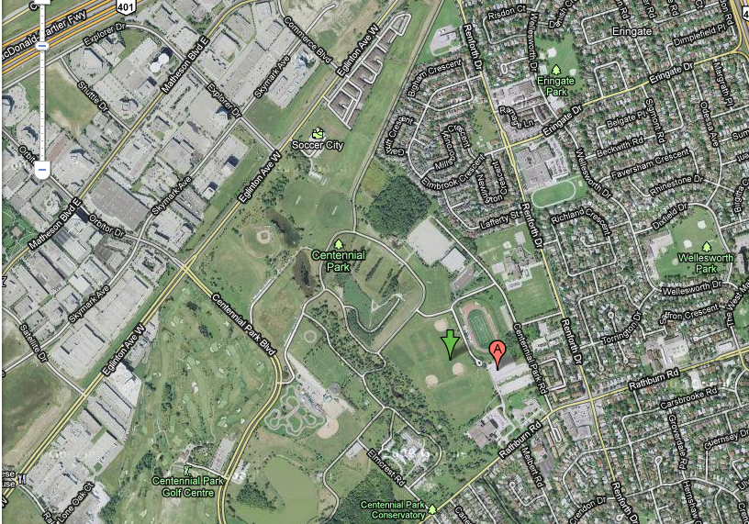
256 Centennial Park Rd

Schedule of Events

REGISTRATION:
All athletes, coaches and volunteers may register between 8:00-8:30 at the registration table located between diamonds. Registration fees $ 10 per athlete to be paid.
Follow the signs.

COACH MEETING:
There will be a mandatory Head Coach meeting for Softball 8:30am.

OPENING CEREMONIES:
Opening Ceremonies will commence at 8:40 am

LUNCH:
Lunch will be provided for all athletes, coaches and volunteers.

CLOSING CEREMONIES:

**results and ribbons will be mailed to head Coaches/Team managers the following week.

Tournament Rules
(superseding SOC/SOO rules) as follows:

Re. Rule 3: All players registered will be on the lineup card and constitute a full batting lineup – the lineup will not be limited to 10 players as per SOC rules. Teams will be allowed free substitutions, but must ensure equal playing time in the field (no player can play more than an inning more than any other player on the roster in any given game).
Re. Rule 4: To facilitate more game play, no new inning will begin after one hour.
Re. Rule 5: An inning will end immediately if the batting team scores 10 runs in the inning or has batted through 12 players in the inning (regardless of how many batters are in the line-up).

ARTICLE IX

Slo-Pitch Softball

The Special Olympics Canada (SOC) Sports Rules shall govern all SOC Slo-Pitch Softball competitions. As a national sports program, CSO has established these rules based upon Softball Canada’s Rulebook. The Softball Canada Rulebook shall be employed except when it is in conflict with the SOC Official Rules and National Policies and Procedures. In such cases, the following SOC Official Slo-Pitch Softball Rules shall apply.

SECTION A

Official Events

- Co-Ed Slo-Pitch Softball.

SECTION B

Rules Of Competition

- Teams will not be required to adhere to a male/female player ratio.

- In the classification (seeding) round, teams will play one or more games. The “game” shall consist of one full inning for both teams. Each team will be required to play all players whose names appear on the final team roster.

- A final team roster consists of a minimum of twelve (12) players and a maximum of fifteen (15) players. All players listed on the final team roster must have an opportunity to play during the course of the tournament.

*NOTE: A final team roster is a complete list of all players registered with the team.

- A regulation game shall consist of seven innings or one
- A mercy rule shall be imposed, if after five full innings of play, one team leads another by ten runs or more, the game will be called.

- The distance between home plate and the pitching rubber shall be between 40’ and 50’. Therefore, a moveable pitching rubber is required.

- A designated runner is allowed for the catcher in a two (2) out situation. The player in the catcher position will bat and must advance to at least first (1st) base before a courtesy runner can be put in. The last (2nd) out in the current inning shall be the courtesy runner.

SECTION C

Equipment and Safety

- The ball shall be eleven and three quarter inches and marked with the “official softball” on the cover. A red stitch, restricted flight ball will be used at National Games.

- Helmets must be worn by batters and base runners.

- A catcher is required to wear a face mask, helmet and throat protector. Leg pads are optional.

Athlete Information

Please register each athlete and coach participating in the competition by following
All entries must be received by June 14, 2013 to

Yunus Tughra at (416) 447-8326 x277 or yunust@specialolympicsontario.com

Please fill out the following form

Athlete Information
 | NAME:  LAST – FIRST | S.O.O  REG. # | GENDER: M/F | D.O.B.  D/M/Y
1
2
3
4
5

6

7

8

9
10

